4th Grade Mathematics Lesson Plan

Presented at the Chicago Lesson Study Conference  
May 3 & 4, 2012  
Prieto Math and Science Academy

Unit designed by Akihiko Takahashi  
Instructor: Tom McDougal

# Title of Unit: Finding the Area of Composed Shapes

# Goals:

## To deepen students’ understanding of the concept of measuring area through problem solving.

## To develop the concept of using equivalent-area transformations and doubling-area transformations as the basis for finding the formulas for the area of a parallelogram, a triangle, and a trapezoid.

## To recognize that the area of composed shapes can be found by transforming them into a rectangle or a square.

## To foster students’ ability to solve problems by providing challenging problems by:

### encouraging students to use prior knowledge to solve challenging problems by themselves,

### encouraging students to see common properties and relationships among various solutions presented by their peers in order to find a better solution to the problem, and

### encouraging students to look at their solutions from a different perspective and develop their ability to use logical reasoning to make conjectures by exposing them to their peer’s different solutions.

## To provide opportunities for students to recognize the importance of working with their peers in order to deepen their understanding of mathematics.

# Connection to Prior and Future Learning

Topics of Measurement in Grades 3–5

* Understand the need for measuring with standard units and become familiar with standard units in the metric system.
* Understanding the concept of measuring area.
* Understand the formula for finding the area of a square and a rectangle.

Topics of Geometry in Grades 3–5

* Investigate, describe, and reason about the results of subdividing, combining, and transforming shapes.
* Know the definitions and properties of basic geometric figures: triangles, squares, rectangles, palallelograms, trapezoids, and rhombi.

**This Unit**

Develop reliable strategies for using formulas for finding the area of a square and a rectangle to find the area of composed shapes.

Measurement for Grades 6–8

Develop, understand, and use formulas to find the area of triangles, parallelograms, trapezoids, and circles and develop strategies to find the area of more complex shapes.

# Unit Overview

# Shapes and Area: Four lessons total

### Through finding the area of a L shape using previously learned knowledge, students will develop reliable strategies, such as decomposing the shape into rectangles or equivelant-area transformations, to find the area of composed shapes.

### Apply the strategies to find similar composed shapes to become comfortable using the concept and the strategy.

### Through finding the area of a rhombus in a rectangle, using previously learned knowledge, students will further develop reliable strategies, such as decomposing and rearangeing the shape into rectangles, or use doubling-area transformations, to find the area of composed shapes.

### Apply the strategies to find similar composed shape to become comfortable using the concept and the strategy.

# Instruction of the Lessons

The lessons consisting of the series of two problem solving activities are planned to help students to be able to extend existing knowledge and develop a foundation for finding the formula for the area of a parallelogram, a triangle, and a trapezoid.

The basic assumption of teaching the area formulas is that students will be able to develop formulas for finding the area of a parallelogram, a triangle, and a trapezoid by using the prior knowledge gained from finding the area of a rectangle and a square. In other words, this means that students are expected to develop the formulas by using their prior knowledge, in this case, the formula of finding the area of a rectangle and a square. In order to do so, students should develop not only the basic concept of area and the measurement of area using formal units, but they also must develop reliable strategies to use this prior knowledge.

One way to help students develop these formulas through such investigation is to provide them with a series of problem solving lessons using manipulatives to develop the concept of equivalent-area transformation. Equivalent-area transformation is a key concept necessary in developing the formulas for finding the area of parallelograms, triangles, and trapezoids. This idea is developed by incorporating students’ prior knowledge, such as using the formula for finding the area of a rectangle and a square. Therefore, it might be a good idea to provide lessons designed to help students develop the concept of equivalent-area transformation prior to the lessons designed to investigate the formula for finding the area of parallelograms, triangles, and trapezoids specifically. This can be accomplished through a series of open-ended problem solving activities tha were developed based on Japanese problem-solving teaching methods/activities commonly used in Japan.

Two lessons for this unit have been based on the idea of teaching through problem solving, which Japanese mathematics educators have been incooporating in their curriculum since 1970. These lessons, based on teaching through problem solving, are designed for students to build strategies to develop the area formulas using their prior knowledge of measuring areas of rectangles and squares. A key strategy for students to develop these formulas is based on the concepts of decomposing a shape and rearranging its components to make more familiar shapes without changing the area of the original shape. Japanese mathematics educators call this strategy the equivalent-area transformation. Another key strategy is called doubling-area transformation. This strategy is to put two congruent shapes together to make a shape of which the students already learned how to find the area. For example, students can find the area of a right triangle by putting them together to make a rectangle or a square. They can find the area of the right triangle from the area of the rectangle or the square by dividing it by two.

The first lesson of this unit is designed for the students to find the area of a composed shape that is made up of rectangles and squares using this concept. Through the problem solving, students will develop strategies to use their prior knowledge to find the area of the composed shape by coming up with their own strategy and discuss what might be a relaible strategy for the furure learning of finding the area of various shapes, the equiverant-area transformation. The second lesson is designed for students to extend their strategy for finding the area of the shape that consists of triangles that are made by cutting a rectangle in half. This problem solving requires students to not only decompose a shape into rectangles and squares, but also to use the knowledge that a rectangle or a square is made up of two congruent right triangles, doubling-area transformation. Through these two problem solving lessons, students are expected to develop two major strategies to use their prior learning to find the area of variety of shapes and be ready to develop the formlua for findng the area of a parallelogram, triangle, and trapezoid.

# Lesson Procedure

### Lesson 1: Through finding the area of a L shape using previously learned knowledge, students will develop reliable strategies, such as decomposing the shape into rectangles or equivalent-area transformation, to find the area of composed shapes.

|  |  |  |
| --- | --- | --- |
| Learning Activities  Teacher’s Questions and Expected Students’ Reactions | Teacher’s Support | Points of Evaluation |
| **Introduction** Find the area of this rectangle.  4cm  5cm   1. Counting the number of unit squares 2. Using the formula for finding the area of rectangle, | Let students find the area by recalling what they learned previously.  Help students recall the formula for finding the area of a rectangle, , and ask students to explain what this formula means. | Do the students recall the formula for finding the area of a rectangle as well as the idea behind the formula? |
| **Posing the Problem** Find the area of the following shape. | Give each student a worksheet with a picture of the shape so that students can record their ideas about finding the area.  Let students know that any ideas about finding the area based on their previous knowledge are acceptable. | Do students understand the problem? |
| **Individual Problem Solving**  * 1. Determine how to find the area of the shape by: counting the number of unit squares in the shape.   2. Dividing or transforming this shape into the shapes that students already know how to find the area by using a formula.     4x3 + 2x2=16 2x3 + 2x5=16 4x5 – 2x2=16 | Provide students with worksheets to keep their work for whole class discussion.  Encourage students to recall what they learned in previous mathematics lessons. | Can each student find at least one way to find the area? |

|  |  |  |
| --- | --- | --- |
| 1. **Comparing and Discussing Students’ Solutions**   (1) Ask students to explain their solution methods to the class.  (2) Facilitate students’ discussion about their solutions in order to understand their ideas behind each solution. | Write each student’s solutions on the blackboard in order to help students understand the discussion. | Can each student understand that there are several ways to find the area? |
| 4. **Find a Strategy to Solve this Kind of Problem**  The area of the shape can be found by dividing the shape into rectangles and squares, or transforming it into a rectangle or a square. |  |  |
| 5. **Summing up and Journal Writing**  (1) Using the writing on the blackboard, review what students learned through the lesson.  (2) Ask students to write a journal entry about what they learned through this lesson. |  |  |

### Lesson 2: Apply the strategies to find similar composed shape to become comfortable using the concept and the strategy.

Students will complete the following exercises:

Find the area of the following shape:

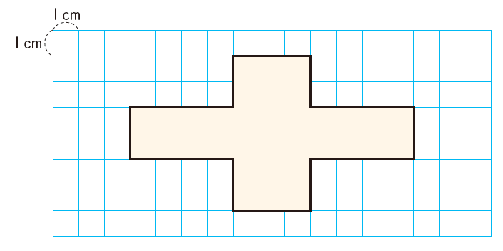

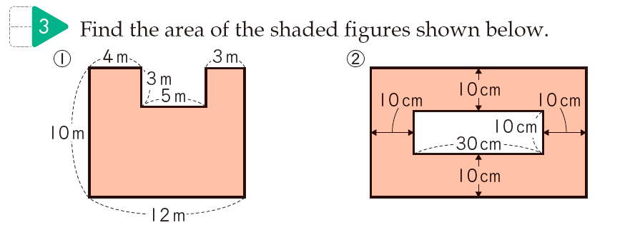

### Lesson 3: Through finding the area of a rhombus in a rectangle, using previously learned knowledge, students will further develop reliable strategies, such as decomposing and rearangeing the shape into rectangles, or doubling-area transformation, to find the area of composed shapes.

|  |  |  |
| --- | --- | --- |
| Learning Activities  Teacher’s Questions and Expected Students’ Reactions | Teacher’s Support | Points of Evaluation |
| **Posing the Problem** Find the area of the shaded part of the following rectangle.  (the measurements of the rectangle is 6cm by 8cm) | Give each student a worksheet with a picture of the shape with 1cm grid so that students can find the nessesary mesurements by themselves in order to find the area.  Let students know that any ideas about finding the area based on their previous knowledge are acceptable. | Do students understand the problem? |
| **Individual Problem Solving**  * Dividing or transforming this shape into the shapes that students already know how to find the area by using a formula.   a) Since each right angle triangle is a half of the small rectangle, which is one fourth of the rectangle, the area of the shaded part is a half of the rectangle. $$6×8÷2=24$$ b) Cutting the shaded part into four equal-size right-angle triangles. Moving two of these triangles to rearrange the shaded part into a rectangle. The measurements of the horizontal side of the new rectangle does not change but the mesurement of the vertical side of the new rectangle becomes a hald of the original rectangle. Thus the area of the shaded part would be a half of the original rectangle. $$\left(6÷2\right)×8=24$$ | Encourage students to find a couple of different ways to find the areas.  Provide students with worksheets to keep their work for whole class discussion.  Encourage students to recall what they learned in previous mathematics lessons. | Can each student find at least one way to find the area? |
| 1. **Comparing and Discussing Students’ Solutions**    1. Let the students to explain their solution methods to the class.    2. Facilitate students’ discussion about their solutions in order to understand that the area of the right angle triangle of the shaed part can be found by using the formula for finding the area of rectangle.    3. Let students see the area of the shaded part, rhombus, is a half of the rectangle. Thus the area of rhombus can be found using the formula $diagonal×diagonal÷2$ | Write each student’s solutions and on the blackboard in order to help students understand the discussion.  Help students recall the name of the shape of the shaded part, rhombus. |  |
| 1. **Extending the Problem** What would happen to the area of the shaded part if the shape of the shaded part changed like the diagram below?   Help students to develop an argument, the area of the shaded part will always be half of the area of the rectangle. | Using the Geometer Sketchpad to display what would happen to the shape of the shaded part in the locations of its diameters.  Use the Geometer Sketchpad to see if the area of the shaded parts stay the same. | Can each student understand that there are several ways to find the area? |
| 1. **Summing up and Journal Writing**    1. Using the writing on the blackboard, review what students learned through the lesson.    2. Help students see the area of rhombus can be found easily when the relationship between the area of the rectangle and the right angle triangle is used by dividing the rectangle into half using one of its diagonals.    3. Each student will organize his/her own solutions to the problems and write a reflective journal of what and how he/she has learned from the class. |  |  |

### Lesson 4: Apply the strategies to find similar composed shapes to become comfortable in using the concept and the strategy.

Find the total area of the shaded parts.

P

Find the total area of the shaded parts if the location of P changes. What will happen if the location of P becomes one of the sides of the rectangle like the figure below?