Board writing plan for lesson 3 to help students develop strategies to find the area of shapes.

Goals of the lesson:

* To deepen students’ understanding of the concept of measuring area through problem solving,
* To develop the concept of equivalent-area transformation as the basis for finding the formulas for the area of a parallelogram, a triangle, and a trapezoid, and
* To provide opportunities for students to recognize the importance of working with their peers in order to deepen their understanding of mathematics.

Let’s find the area of shapes

What we did yesterday

Find the area of rectangle  
Length x Width

Find the area of square

Side x Side

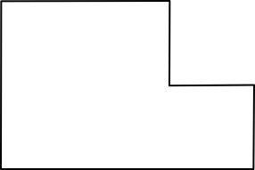

Find the area of the shaded part of the rectangle.

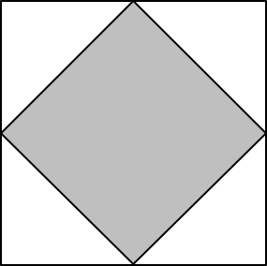

By counting the number of the unit square

What would be the area if the shape of the shaded area changes?

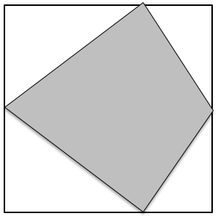 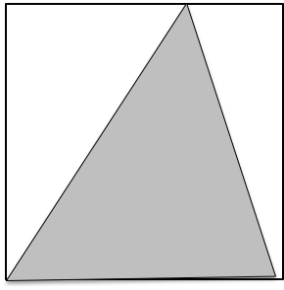

Are of the shaded part will stay the same.

Are of the shaded part is a half of the area of the square.