Lesson Research Proposal for 2nd Grade

For lesson on: May 6 at Prieto Math and Science Academy,
Ms. Jorgensen’s class
Instructor: Bethany Jorgensen
Lesson plan developed by: Chavez Second & Third Grade Teams

Title of the Lesson: Using Tape Diagrams to Illustrate our Thinking

Brief Description of the Lesson
During this lesson, second grade students will use a tape diagram to demonstrate their thinking as they solve for the unknown starting amount in a change-decrease problem.

Research Theme
Our research theme is for students to be able to communicate their ideas and strategies, and be able to justify and/or critique their reasoning. This skill will help them make sense of and apply strategies that they have learned from their peers. This relates to Standards for Mathematical Practice 3 (construct viable arguments and critique the reasoning of others) and 1 (make sense of problems and persevere in solving them).

Goals of the Unit
- For students to become flexible mathematical thinkers, unreliant on the specific wording of a problem (key words).
- To help students understand that bar models can be used to represent many different types of addition and subtraction problems.
- To help students understand that bar models should be strategically proportional; that the size of each bar matters.
- To help students understand that although bar models are effective for representing problems, algorithms should be used to solve them.
- To help students understand that there are multiple number sentences that can be used to represent a problem.

Goals of the Lesson:
- Students will understand that the operation needed to solve a problem depends on what is unknown.
- Students will be able to use and label a tape diagram to express the relationships in a problem for which the starting amount is unknown.
- Students will recognize that addition is needed to solve for the unknown starting amount in a change-decrease problem.

Relationship of the Unit to the Standards

Related prior learning standards | Learning standards for this unit | Related later learning standards
CCSS.Math.Content.1.OA.A.1: Use addition and subtraction within 20 to solve word problems involving situations of adding to, taking from, putting together, taking apart, and comparing, with unknowns in all positions  CCSS.Math.Content.1.OA.B.3  Apply properties of operations as strategies to add and subtract.  CCSS.Math.Content.1.OA.D.8  Determine the unknown whole number in an addition or subtraction equation relating three whole numbers. | CCSS.Math.Content.2.NBT.B.7  Use addition and subtraction within 100 to solve one- and two-step word problems involving situations of adding to, taking from, putting together, taking apart, and comparing, with unknowns in all positions  CCSS.Math.Content.2.NBT.B.5  Fluently add and subtract within 100 using strategies based on place value, properties of operations, and/or the relationship between addition and subtraction. | CCSS.Math.Content.3.OA.D.8  Solve two-step word problems using the four operations. Represent these problems using equations with a letter standing for the unknown quantity.  CCSS.Math.Content.3.NBT.A.2  Fluently add and subtract within 1000 using strategies and algorithms based on place value, properties of operations, and/or the relationship between addition and subtraction.

Background and Rationale

2nd and 3rd graders need extra strategies to persevere in solving word problems with missing addends, subtrahends or totals. We want our students to develop a deeper understanding of addition as adding to/putting together and subtraction as taking from/taking apart. Students struggle to identify the missing information and subsequently the process that needs to be used in order to find that missing information. We decided to address these difficulties with word problems by having our students practice using tape diagrams, a.k.a bar models, as the primary tool to help solve problems and using them to correctly illustrate their thinking.

Our unit is sequenced in a way that will build understanding from concrete, to semi-concrete, to abstract reasoning. For example, the introductory lesson involves solving a word problem in which students can use a tape diagram that has been divided into individual units, or counters, to see the total amount or check for missing information. In this case, counting is an effective strategy, but we emphasize the use of a number sentence to represent problem situations.

As the unit progresses and larger numbers are used we begin to use the tape diagram without counters as a way for students to make sense of the relationship between the given quantities. Further, the tape diagram helps students first identify the unknown, and then decide how subtraction and/or addition can be used to solve for the unknown. Throughout the unit, we expose students to various story contexts, each with different unknowns, so that students can develop an understanding of how to use the tape diagram to represent each of these unknowns and ultimately use subtraction and/or addition to solve.

In keeping with the research theme, by the end of the unit, students should be able to calculate, using subtraction or addition, to solve a variety of story problems and a tape diagram to represent their thinking in the various story contexts. Students will be encouraged to move away from an over reliance on key words and to logically think through a story problem using tape diagrams to model their thinking. They should also be able to explain the meaning of these numbers as they relate to the context of the word problem. In so doing, the students will have moved considerably toward mastery of Common Core State Standard 2.OA.A.1.

Research and Kyozaikenkyu
We began our research by reflecting on our unit on addition and subtraction story problems from last year. In last year’s unit we had students create bar models by cutting lengths of paper made from centimeter squares and joining them together or separating them. As a result of this instructional choice, students used the models themselves to solve the problem. As a result, instead of using subtraction, they solved by “counting on” from the smaller number in order to find the difference.

Dr. Takahashi’s final comments at our research lesson at last year’s conference gave insight as to why it was not helpful to have students make their own bar models. Since students could see the individual units within the bars, they used the bars themselves as a method for finding the solution. As Dr. Takahashi explained, models and diagrams in mathematics are not tools for solving. Rather, they are methods of representation. One explanation that stuck with us was the idea of “representation” as, literally, “re-presentation.” The initial presentation of quantities and their relationships within word problems can often be tricky (especially because of linguistic concerns). A model can help clarify these relationships because it is a way of presenting them, again, in a simpler way.

Instead of focusing on the types of addition/subtraction word problems, we decided to focus our research on bar models and how to improve how we use them in our instruction. In Mathematics International, Grade 2, we can see a progression in helping students make the transition from using counters to using units of length in bar models/tape diagrams. Chapter 3 presents a part-part-whole problem (“How many books are there in all?”) with a diagram that shows different-colored counters, with each color representing a different number. A rectangle is drawn around the counters to show the length of the bars that would represent them.

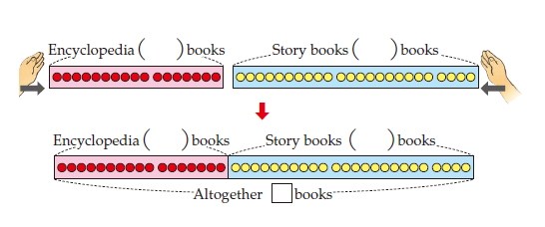

Chapter 4 presents a change-­decrease problem with an unknown change. A class begins with 41 books, and now only has 15 books. How many books were borrowed? As can be seen in the model below, the counters show the known books, with a blank bar (no counters) representing the unknown number of books that were borrowed. And below the bar: “The diagram shows the number of books with an approximate length.” Students are encouraged to write a number sentence and use subtraction to solve.
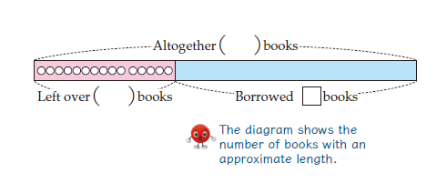
Chapter 16 (“Let’s Think about Using Diagrams”) begins with a review of the diagrams that have been used thus far in 1st and 2nd grade. On the page, there is a sequence of diagrams to represent a part-part-whole and a change-decrease problem: the first example shows only counters, while the second shows counters enclosed in rectangles. The third example shows only the rectangles, the same lengths as before, with no individual visible counters. Again, there is a helpful explanation: “…We expressed the quantity using length in the diagram.”
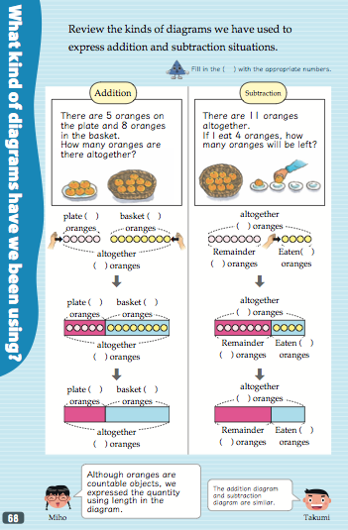
As can be seen, children’s understanding of the bar model develops over time until it reaches its first fully-formed use at the end of 2nd grade. The first complete lesson of the chapter involves a part-part-whole scenario involving red and blue sheets of paper. All numbers are given. Students must first show the situation using a bar model. Then they think about scenarios in which each number is missing. They consider what number sentence they would use to represent the situation, and what operation they would use to solve. This lesson is important in helping students see the relationship between all three numbers, and sets the stage for students to be able to solve for any unknown in future story problems.
Researching this progression of understanding throughout Mathematics International was vital for us in our planning. We interpreted the lessons from Chapters 3 and 4 as background for our unit. This part of our research helped us support students who had not yet made the transition from needing to see a chain of individual units to understanding that the bars themselves represent quantities. The rest of our unit is based on lessons from Chapter 16 in MI. Unlike last year, we decided to not include comparison story problems in this unit, as these involve a slightly modified bar model. This unit focuses on part-part-whole, change-increase, and change-decrease contexts, with the unknown in any place. Our 2nd grade students will continue their investigation of bar models in 3rd grade by using these diagrams to represent comparison problems.

Unit Plan
Lesson | Learning goal and tasks
1 | Introduction to tape diagram  Part 1: Use cubes to visually represent problem.  Part 2: Transition to tape diagram given part, part, whole. “There are some sheets of red and blue paper. There are 60 sheets of colored paper altogether. Of these, 35 sheets are red and 25 are blue. Show this situation using a diagram.”
2 | Using tape diagrams and addition to solve a part-part-whole (unknown whole) problem.  “There are 17 encyclopedia books. There are 24 story books. How many books are there in all?”
3 | Using tape diagrams with subtraction algorithm to solve a change-decrease (unknown result) problem.  “Yuki’s class library has 41 books altogether. Now they have 15 books left. How many books have been checked out?”
4 | Tape diagram addition and subtraction practice day
5 | Students represent and solve a change-increase (unknown change) problem. Students use subtraction to solve.  “There were 15 oranges. We bought more oranges, and now there are 32 oranges. How many oranges did we buy?”
6  Research  Lesson | Students represent and solve a change-decrease (unknown start) problem. Students use addition to solve.  “Ms. Jorgensen brought cookies for the class. She passed out 36 cookies and now has 19 cookies left in the box. How many cookies did she have at first?”
7 | Missing addend (given or missing start) practice day
8 | Practice: students solve a variety of word problems

Design of the Unit and Lesson
We designed our unit with a focus on systematically developing student’s understanding and use of the bar model in representing addition and subtraction scenarios.

a. The Contents
This unit helps students make sense of a variety of addition and subtraction word problems (CCSS.2.NBT.B7), and does so in a way that builds a foundation for future content. By teaching the bar model as a tool for representing mathematical contexts, we address not only the content standards of 2nd grade, but lay the groundwork for approaching future standards that involve more sophisticated relationships within story problems.

b. Cognitive Demand
Each lesson in our unit achieves a balance between ideas that students are familiar with and new challenges that students must approach using their prior learning. By using a teaching through problem solving approach, we challenge students to solve a problem that has something new in it relative to what they have learned before. When students move from a part-part-whole to a change-decrease scenario, or from a story context with a missing change to one with a missing initial amount, students must use their previous understanding as a bridge to new discoveries.

c. Equitable Access to Content
The bar model is a useful tool for students to communicate their understanding of mathematical relationships to their peers. We want to ensure that all students have the same access to this content. As the focus will be on appropriate uses of the bar model, we will provide certain students a pre-written bar model with labels. This accommodation will provide equitable access to content, in that these students will only have to match the numbers in the story context to the appropriate bars.

d. Agency, Authority and Identity
In many of the lessons of the unit, including the research lesson, students (as opposed to the teacher) will be responsible for the majority of the ideas that are presented and discussed. Lessons 5 and 6 will be particularly good opportunities for developing agency and authority among students, as the sophistication of these problems will most likely lead to a lively debate about whether to use addition or subtraction.

e. Uses of Assessment
We will use formative assessment to understand how our students’ thinking changes as they solve new problems from lesson to lesson. Our main tools of formative assessment will be to observe their journal work, listen to their mathematical arguments in discussion, and analyze their written reflections. Some of the questions we will think about as part of our assessment include: How do students decide what operation to use when solving a story problem? To what extent does using a bar model help students make sense of the problem and decide on a number sentence? Do students see the usefulness of bar models in explaining their understanding of a problem to others?

Research lesson plan
Steps, Learning Activities  Teacher’s Questions and Expected Student Reactions | Teacher Support | Assessment
- Introduction  Have students read their reflections on previous lessons:  Michelle: “Today I learned that I have to use addition to add up the parts to find the missing whole.”  Emily: “Today I learned that if a part is missing you need to subtract to find it.”  Student reflections about how tape diagrams help us solve problems. | Teacher will model Michelle and Emily’s ideas underneath their reflection.
- Posing the Task  “Ms. Jorgensen brought cookies for the class. She passed out 36 cookies and now has 19 cookies left in the box. How many cookies did she have at first?”  Teacher reads the problem  Students re-read the problem, glue it into their math notebook and start solving it | A few students will receive a blank tape diagram as an accommodation.
- Anticipated Student Responses  Incorrect Answers:  R1: Use subtraction algorithm.  (36 – 19 = 17)  R2: Use subtraction algorithm and use tape diagram incorrectly.  (36 – 19 = 17)  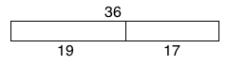  Correct Answers:  R3: Use addition algorithm.  (36 + 19 = 55)  R4: Use addition algorithm and use tape diagram correctly.  (39 + 19 = 55)  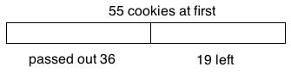 |  | How many students are drawing a tape diagram to help them solve the problem?  Are the students using a tape diagram to actually help them solve the problem, or are they just plugging the numbers in quickly?  Are students adding to find the missing starting amount?
4. Discussion of Strategy with Partner  Students will turn and talk to a partner to explain their strategy.  “Turn and talk to your partner. First, find out how they solved the problem, and then decide if you think their solution is correct.” |  | Are the students able to point out each other’s misconceptions about the problem using the tape diagram as justification?
5. Comparing and Discussing  Students using only algorithms (without tape diagram) write down strategy on board and explain their thinking.  R1: Subtraction algorithm.  (36 - 19 = 17)  R3: Addition algorithm.  (36 + 19 = 55)  Students who used a tape diagram and an algorithm write down strategy on board and explain their thinking.  R2: Subtraction algorithm and use tape diagram incorrectly.  (36 - 19 = 17)  R4: Addition algorithm and use tape diagram correctly.  (39 + 19 = 55)  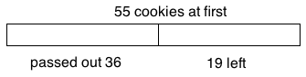 | Teacher will write down student ideas above strategies during class discussion.  Teacher questions to guide discussion:  - Which solution do you agree with, and why?  - Which solution doesn’t make sense to you, and why?  - How does the tape diagram help you understand how to solve the problem? | Are the students articulating the need to add since the starting amount is missing?  Are the students able to recognize that a tape diagram aids in making sense of a problem by identifying what’s missing?
6. Summing up  Summary Statement: Sometimes we use addition to find a missing starting amount.  Students will write a reflection about what they learned in their notebook.  Teacher will choose 4-5 students to share their reflection for the group. |  | Are the students able to articulate in their own words why we used addition in this problem?  Are the students organically writing about the usefulness of a tape diagram?

Evaluation
- Does the lesson effectively support students in using diagrams, number sentences, and verbal explanations to explain and justify their thinking?
- Do students understand that in a “take-away” situation, if the start amount is unknown then we must use addition to solve?
- To what extent does the tape diagram help students to make sense of the story's context and understand the relationship between its numbers?

Board Plan
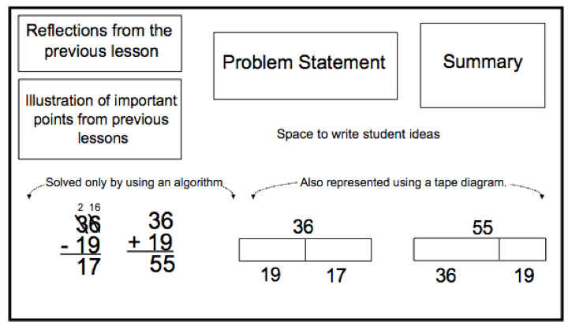

Reflection
(to be added by the team after the lesson and discussion)

