CLR[1]-TRU Math[2] Lesson Research Proposal for 4th grade fractions

For the lesson on May 5, 2016
Chicago Lesson Study Conference
Dr. Jorge Prieto Math and Science Academy
Instructor: Alex Johansen
Lesson plan developed by: Alex Johansen, Mary Espinosa, Yael Berenson, Maria Rosario, Andrea Calhoun, Andrew Friesema, Mariel Laureano

1. Title of the Lesson: Let’s think about how to calculate ¼ + ⅜

2. Brief description of the lesson: Students will apply what they have already learned about unit fractions, equivalent fractions, and the comparison of fractions with both like and unlike denominators to think about how to add fractions with different denominators in which one denominator is a divisor of another so that only one fraction has to be changed.

3. Research Theme
Teach scholars to construct viable arguments and critique the reasoning of others through note-taking, board work, and student discourse.
Teach scholars to make sense of problems and persevere in solving them by teaching mathematics through problem solving.
Explanation of the research theme:
If scholars record their reasoning in their notebook, this will support them in explaining their thinking orally to others. If they also use their notebooks to record the reasoning of others, this will lead them to think critically about what their fellow scholars are saying before they write it down.
Careful use of the board by the teacher can support students in several ways. The teacher can model what students should write in their notebook. Also, by presenting multiple solutions simultaneously on the board (instead of using an overhead projector or document camera), this will help students compare and contrast those solutions and facilitate discussion about them.
If students are to have a substantive discussion, they need something substantive to discuss, something more than "This is the way you are supposed to do it." If we start most lessons by challenging students to solve a problem that requires some new way of thinking, students will come up with different strategies, the merits of which they can then discuss. And our student get another benefit from this approach, which is that they become habituated to solving unfamiliar problems, and thus better at understanding problems and persevering.
4. Goals of the Unit
Students will be able to:
- Operate with fractions (fractions as units)
  - Use understanding of operations with fractions as extension of operations with whole numbers
- Understand fractions as parts of a whole (1 whole)
- Decompose fractions as a sum of unit fractions ⅔ = ⅓ + ⅓ ; ⅚ = ⅙ +⅙ +⅙ +⅙ + ⅙
- Add and subtract with fractions, less than one (⅗ + ⅕ = ⅘) and greater than one (⅗ + ⅘ = 7/5)
- Decompose unit fractions as a sum of smaller unit fractions ⅓ = ⅙ + ⅙ = 2/6

- Decompose area models to generate equivalent fractions (shaded parts / total parts)
- Relate the decomposition of an area model to multiplication to generate equivalent fractions (⅔ = 2x4/3x4 = 8/12)
- Use the number line to generate equivalent fractions
- Compare fractions with unlike denominators
- Add and subtract fractions where one denominator is a factor of the other denominator.

5. Goals of the Lesson:
a) Students will understand that in order to add or subtract fractions with unlike denominators they have to change one of the fractions into an equivalent fraction with a denominator the same as the other addend.

b) Students will be able to use visual models and number sentences to find equivalencies in order to add fractions with unlike denominators. Students will be able to communicate their ideas to peers using the models. Students will be able to summarize how to convert one fraction to an equivalent fraction and why this must be done before adding fractions with unlike denominators.

6. Relationship of the Unit to the Standards
Related prior learning standards | Learning standards for this unit | Related later learning standards
3rd Grade  Develop understanding of fractions as numbers.  3.NF.3 Explain equivalence of fractions in special cases, and compare fractions by reasoning about their size.  a. Understand two fractions as equivalent (equal) if they are the same size, or the same point on a number line.  b. Recognize and generate simple equivalent fractions, e.g., ½ = 2/4, 4/6 = ⅔. Explain why the fractions are equivalent, e.g., by using a visual fraction model.  d. Compare two fractions with the same numerator or the same denominator by reasoning about their size. Recognize that comparisons are valid only when the two fractions refer to the same whole. Record the results of comparisons with the symbols >, =, <, and justify the conclusions, e.g., by using a visual fraction model. | 4th Grade  Extend understanding of fraction equivalence and ordering.  4.NF.1 Explain why a fraction a/b is equivalent to a fraction (n x a)/ (n x b) by using visual fraction models, with attention to how the number and size of the parts differ even though the two fractions themselves are the same size. Use this principle to recognize and generate equivalent fractions.  4.NF.2 Compare two fractions with different numerators and different denominators, e.g., by creating common denominators or numerators, or by comparing to a benchmark fraction such as ½. Recognize that comparisons are valid only when the two fractions refer to the same whole. Record the results of comparisons with symbols >, =, <, and justify the conclusions, e.g., by using a visual fraction model. | 5th Grade  Use equivalent fractions as a strategy to add and subtract fractions.  5.NF.1 Add and subtract fractions with unlike denominators (including mixed numbers) by replacing given fractions with equivalent fractions in such a way as to produce an equivalent sum or difference of fractions with like denominators. For example, ⅔ + 5/4 = 8/12 + 15/12 = 23/12. (In general, a/b + c/d = (ad + bc)/ bd.  5.NF.2 Solve word problems involving addition and subtraction of fractions referring to the same whole, including cases of unlike denominators, e.g., by using visual fraction models or equations to represent the problem. Use benchmark fractions and number sense of fractions to estimate mentally and assess the reasonableness of answers. For example, recognize an incorrect result ⅖ + ½ = 3/7, by observing that 3/7 < ½.

7. Background and Rationale
According to the CCSM-M for 4th grade, a significant area of focus for instructional time should be developing an understanding of the meaning of fractions and how to express fractions, learn to focus on equivalent fractions, and understand the meanings of adding and subtracting fractions with like denominators.

An important aspect of this expectation from the CCSS-M is that students have a solid understanding of a fraction as a number. This understanding of a fraction as one number with the numerator indicating quantity and the denominator identifying the unit (⅘ is 4 one-fifths) is important for students to understand as they develop fluency with operations with fractions.

Fractions are a particularly difficult topic for elementary school students because of the various ways that fractions can be used. Students are first exposed to fractions using area, shape, region, and linear models. This part-whole relationship typically has students exploring fractions less than one and up to one. Another way they are introduced is in proportion problems (⅖ of 30 is 12). It can be quite challenging for students to understand ⅖ as both a number on the number line between 0 and 1 as a relative quantity, as in the case of ⅖ of 30 is 12.

The research team believed that although addition of fractions with unlike denominators is a 5th grade standard, it was an important context for students to apply their understanding of equivalent fractions. This problem bridges the difference between the 4th grade and 5th grade standards by illustrating the usefulness of being able to find equivalent fractions.

A school wide goal at Prieto is to encourage student development of the mathematical practices articulated in the CCSS-M through the relationship between student note-taking, teacher board writing, and mathematical discussion. As a professional learning community we have focused on a specific part of SMP 3: Construct viable arguments and critique the reasoning of others. To be able to develop a positive identity as a mathematician, students need to be able to “justify their conclusions, communicate them to others, and respond to the arguments of others.”

Our students are still developing the skills necessary to engage in a comparison and discussion that allows for the free flow of mathematical ideas, justifications, and critiques. The team had this in mind when discussing teacher facilitation moves to model and encourage student to student communication of mathematical ideas.

8. Research and Kyozaikenkyu
In researching the topic of teaching fractions the team began by looking at the Progressions for the Common Core document published by the University of Arizona. According to the Progressions for the Common Core State Standards in Mathematics, students in third grade begin to develop the idea of fractions as equal parts of a whole number with the same measurement. Students use unit fractions as basic building blocks, similar to using the number one to build whole numbers. Adding and subtracting fractions is built upon the idea that fractions are composed of unit fractions. This enables students to add and subtract fractions with the same denominator.
In fourth grade, students must have a solid understanding of equivalent fractions in order to compare fractions and to understand operations with fractions. Students build their equivalency understanding through modeling with area models and number lines. Finding equivalent fractions allows students to compare fractions with different denominators. Additionally, students are able to compare fractions on a number line by looking at where fractions with different denominators lie relative to each other or to benchmark fractions on the number line. Students learn that they can multiply and divide the numerator and denominator of a fraction by the same number in order to obtain an equivalent fraction. In fourth grade this idea is justified using area models. In later grades it can be further understood using the multiplicative identity.
Next the team reviewed Elementary and Middle School Mathematics: Teaching Developmentally by John Van de Walle (2010). Van de Walle stresses that the use of different types of models when teaching fractions gives students concrete visual representation of fractions and their operations. The most accessible way for students to first grasp the concept of equivalencies is to use models when teaching equivalent fractions. Activities that use concrete models allow for students to develop the abstract idea that “fix quantities have infinite number of names”. It is suggested to sometimes use two different models when teaching the same concept because a student may “see” the representation in one model but not the other. The strategic use of a specific model by a teacher helps to broaden a student’s understanding of fractions. For example, “using a region model approach is a good visual and is closely linked to the algorithm. The approach suggests to look for a pattern in the way that the fractional parts in both the part as well as the whole are counted”. This “unitizing” builds the foundation that later supports students with proportional reasoning and comparison of ratios.
Van de Walle also suggest that when students are asked to use a symbolic approach, such as the algorithm, students at this stage of development are left to rely only on their deductive reasoning and aren't sophisticated enough to appreciate the multiplicative identity approach to finding equivalencies. Van de Walle discusses further that developing students mistakenly use the operation “rules” for whole numbers to compute with fractions, for example, 1/2 + 1/2 = 2/4. Allowing for longer explorations in estimation and benchmark recognition, supported by models, helps support students in their develop of fractional number sense.
After a review of the progression document and Van de Walle’s research on teaching developmentally appropriate mathematics, the team next researched instructional materials to see how the topic of teaching fractions is dealt with in different curriculums. In Tokyo Shoseki’s Mathematics International (MI) Grade 4, Unit 12, “Let’s Investigate Fractions in Detail”, students develop their understanding of the meaning of fractions and how to express fractions, learn to focus on equivalent fractions, and understand the meanings of adding and subtracting fractions with like denominators. These important topics in MI, understanding the size of unit fractions, how to do addition and subtraction calculations involving fractions with like denominators, and focus on equivalent fractions were important in leading up to the research lesson. The development of this research lesson is intended to guide students with their understanding of equivalent fractions and its application to the meaning of adding and subtracting fractions with unlike denominators, and how to do such calculations.
In Mathematics International Grade 5, Unit 10, lessons are designed to allow students to understand the properties of fractions, the meaning of adding and subtracting fractions with unlike denominators, and how to do such calculations. By finding a common denominator, students think in terms of how many of the unit fraction there are. This concept is the basis of addition and subtraction calculations that are calculated after matching the units, whole numbers, decimal numbers, and fractions all use this concept. Once students are helped to realize that they are doing calculations between numbers with the same unit, they will be able to think about addition and subtraction calculations in a more comprehensive manner.
After looking at MI, the team next looked at the EngageNY unit in fractions. The EngageNY fractions unit, Module 5, starts with the concept of fractions as units. If students understand that 3 bananas + 2 bananas = 5 bananas, then they know that three eighths + two eighths = 5 eighths.
Students are introduced to fractions through paper folding to create fraction strips, which lends itself to the tape diagram. Students move from the tape diagram to the area model (to show multiplicative relationship), then to the number line (derived from the tape diagram), decomposing each to find equivalent fractions.
Students’ first exposure to generating equivalent fractions is through decomposing the area model. Students then use this area model to demonstrate how equivalent fractions can be created through multiplication and division (multiplying and dividing the numerator and denominator by the same number, i.e. one). Students continue to increase their capacity for justifying fraction equivalency by relating the tape diagram to the number line. This will allow them to eventually reason using benchmark fractions of 0, ½, 1, 1 ½, and 2 in order to perform operations with unlike denominators.

9. Unit Plan

Lesson | Learning goal and tasks
1 | Students will understand that in order to compare fractions with unlike denominators, they need to create equivalent fractions so that the fractions they are comparing have the same size unit fraction.  Students will compare fractions with unlike denominators where one denominator is a multiple of the other using area models or compare the two fractions on a number line.  “Let’s think about how to compare ⅔ and ⅚ .“
2 | Students will understand that to be able to compare, they have to have the same size pieces (common denominator) and will appreciate how using a/b = (a x n) / (b x n) to find an equivalent fraction is useful in problems where drawing an area model would be impractical.  Students will compare 2 fractions with unlike denominators where the one denominator is not a factor of the other fraction’s denominator.  “Let’s think about how to compare ¾ and ⅘ ”
3 | Students understand and formalize a/b = (a x n) / (b x n) based on specific area model comparisons from previous lessons.  Practice day: students practice creating equivalent fractions in order to compare fractions with different but related denominators (one denominator is a factor of the other).
4 | Research Lesson: Students will understand that to add two fractions they have to have the same denominator because the denominator represents the the unit fraction.  Students will be able to add two fractions with unlike denominators when one denominator is a factor of the other fraction’s denominator by using what they have learned about equivalent fractions.  “Let’s think about how to add ¼ + ⅜.”
5 | Practice Day: Students will practice adding fractions with unlike denominators when one denominator is a factor of the other fraction’s denominator using strategies discussed during previous lesson.

10. Design of the Unit and Lesson

a. The Mathematics
This unit has been designed to carefully develop student understanding of fraction from concrete representation to abstract number. Through decomposing the tape diagram (ex. splitting each unit fraction of one half into two equal parts, creating fourths.), students are able to see that different fractions can represent the same number. In their tape diagram, ½ takes up the same amount of space as 2/4. This is reinforced when they use their tape diagrams to create number lines and see that ½ and 2/4 are at the same point on the number line. This understanding of equivalent fractions makes it possible for students to compare the values of fractions with unlike denominators, and also leads into our research lesson on operations with fractions that have unlike denominators.

b. Cognitive Demand
The unit has been carefully designed so students are using mathematics they learned previously to learn new mathematics. The progressive design of the unit ensures that students are able to use math that they already know to make sense of a new kind of problem, and through this new kind of problem learn some new mathematics that was previously unknown. This focus on teaching math through problem solving ensures that students are engaged in cognitively demanding tasks that require them to use math the already know to solve a new type of problem. Students will rely on what they have previously learned about using equivalent fractions to compare fractions with unlike denominators, and what they know about operations with fractions to make sense of a new problem in which they have to think about how to calculate ¼ + ⅜ . The fact that this task is brand new to students makes it cognitively demanding. The fact that it is grounded in a context that they are familiar with ensures that it will provide students with a productive struggle that results in new learning rather than a task that is frustrating.

c. Equitable Access to Content
The structure of this lesson has been designed to maximize the active engagement of all scholars. The class is all presented with the same problem so that they have a collective sense of purpose. They are all given individual work time to think deeply about the problem and to write down their ideas in their math notebooks. Partner and table discussions allow for all scholars to listen to their friends mathematical ideas, and express and justify their own ideas using mathematics. The larger whole group comparison and discussion of ideas allows scholars to think about how their ideas and their classmate’s ideas relate to the ideas that other classmates bring forth in the whole group comparison and discussion, and allow them to see how their own ideas fit into the larger math goal of this particular lesson.

d. Agency, Authority and Identity
In designing this lesson the team was careful to consider how to design a lesson that allowed for the authority for the mathematics to reside with the scholars and their mathematics rather than the teacher. The scholars are presented with a problem that they do not know how to solve (¼ + ⅜ ) and are not shown how to solve it by the teacher. The teacher simply asks them to “think about how to calculate” this new type of problem. The teacher asks questions to get scholars to think about what is different about this type of problem? What makes it challenging? The teacher’s role shifts from showing students how to solve problems and giving them mathematics to asking questions and facilitating student investigation so that they derive the mathematics for themselves.

e. Uses of Assessment
The use of student notebooks as the central artifact in the lesson provides an opportunity for ongoing formative assessment. Students are recording their thoughts, feelings, and mathematics in their notebook. In this lesson format, teachers are constantly checking student work, because student ideas form the basis of the comparison and discussion, which is the central portion of the lesson. Basing the lesson on student mathematics rather than the teacher’s mathematics ensures that teachers are consistently assessing student understanding by looking at student ideas in their notebooks and through students using their notebooks to justify their ideas to other classmates. A summative assessment in the form of an exit slip will be administered the day after the research lesson when students have had time to process the comparison and discussion and practice the new learning during the practice day following the research lesson.

11. Research lesson plan
Steps, Learning Activities Teacher’s Questions and Expected Student Reactions | Teacher Support | Assessment
1. Introduction
Teacher will begin lesson by asking class what ⅛ + ⅜ is in order to compare and contrast this problem with the new problem for today, ¼ + ⅜ .
2. Posing the Task  Alonso ran ¼ of a mile on Monday and ⅜ of a mile on Tuesday, how far did he run altogether?  Think of a number sentence that represents how far Alonso ran and write it in your notebook.  ¼ + ⅜ =  “Let’s think about how to add fractions that have different denominators.” | Scholars will write the story of Alonso running Monday and Tuesday in their notebooks as the teacher writes it on the board.  Scholars will discuss what number sentence represents what is described in the story of Alonso running on Monday and Tuesday | Do students recognize that this is an addition situation? That they have to add ¼ and ⅜ to find the total distance ran on Monday and Tuesday.  Do students recognize that they cannot add ¼ and ⅜ because they are expressed using different units? Do they see a need to find equivalent fractions with the same denominator?
3. Anticipated Student Responses

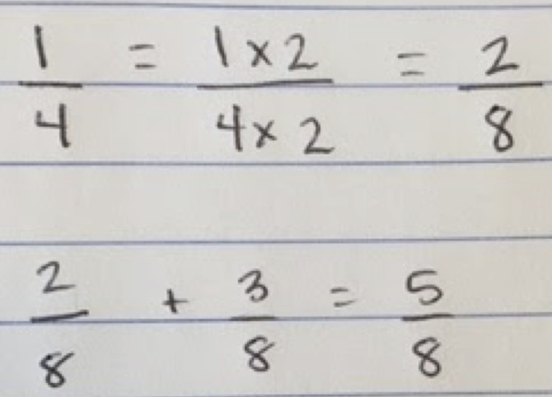
R1: Student recognizes that they cannot add fourths and eighths. They recognizes that four is a factor of eight and that they can make an equivalent fraction for ¼ that has a denominator of 8 so that they can add it to ⅜ .
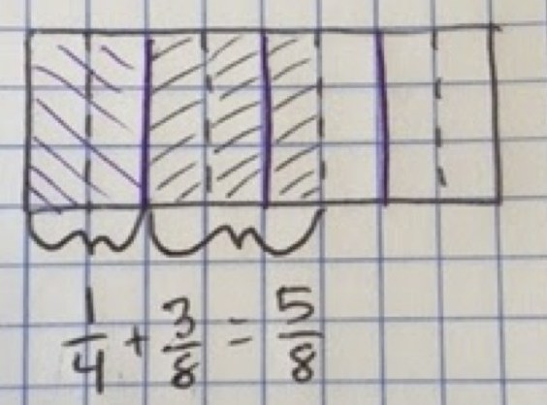  R2: Student represents ¼ with a tape diagram and represents ⅜ with a tape diagram. Student recognizes that they can break their fourths into eighths and count up the number of eighths to find ⅝ . | Students using tape diagrams may count ¼ as two ⅛ s but still notate it as ¼. Ask students questions that make them think about how they calculated ¼ + ⅜ so they see that in their model they changed ¼ into the equivalent fraction 2/8.
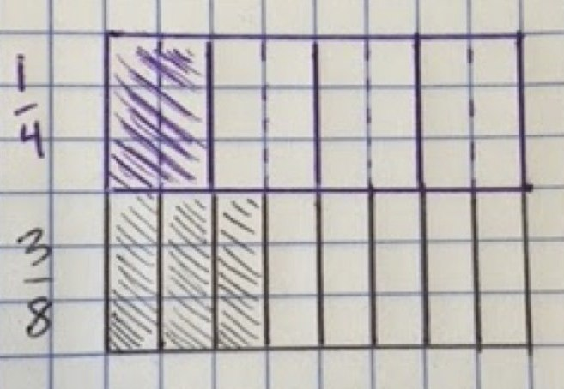
R3: Student represents ¼ with a tape diagram and represents ⅜ with a tape diagram and does not know how to add the ¼ and ⅜ .

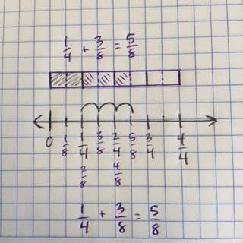
R4: Student uses number line divided into fourths and eighths, starts at ¼ , moves 3 eighths and finds ⅝ on the number line.

4. Comparing and Discussing Begin with a student who got stuck (R3) to clarify what makes the problem difficult.  Next R2: ¼ in half to create two ⅛ pieces and so can add ¼ + ⅜ and find that ¼ + ⅜ is ⅝ .  R4 shares how they used a number line with both ¼ and ⅛ intervals on it to find equivalent fractions to make sense of how to add fractions with unlike denominators.  Conclude w R1:  1/4 = (1x2)/(4x2) = 2/8  so  ¼ + 3/8 = 2/8 + 3/8 = 5/8 | In facilitating the discussion it is important that the teacher asks questions of the student that shares R2 to get them to recognize that when they broke ¼ in two pieces, those two new pieces are each ⅛ , so their number sentence should reflect that. They did not actually add ¼ + ⅜ , they changed ¼ into the equivalent fraction 2/8 so the number sentence should be 2/8 +⅜ = ⅝ .  “Why did you multiply both numerator by 2?” | Do scholars understand that the fractions have different unit fractions and cannot be added together as they currently are represented? Do they understand that an equivalent fraction is needed so that we are adding together the same size units?  Has the area model and number line model justified to all student that ¼ and 2/8 are equivalent?  Do scholars appreciate the efficiency of this calculation relative to creating an area model or a number line?
4. Summing up
“Today as a hard working class we learned that we can add fractions with unlike denominators by using equivalent fractions.”
5. Reflection  Sentence starters for student reflections:  “At first I felt _______ because … but now… “  “My partner showed me … “  “I need to remember…”  “_________’s strategy might be useful the next time I encounter a ___________ problem” |  | What evidence is there in the student reflections that they appreciate the efficiency of R1 and are interested in trying to use it in the future?

12. Evaluation

Do scholars utilize their previous understanding of equivalent fractions and unit fractions to add fractions with unlike denominators?

Does the research lesson design encourage students to justify their ideas using mathematics, to critique the reasoning of others, and to persevere in problem solving?

13. Board Plan
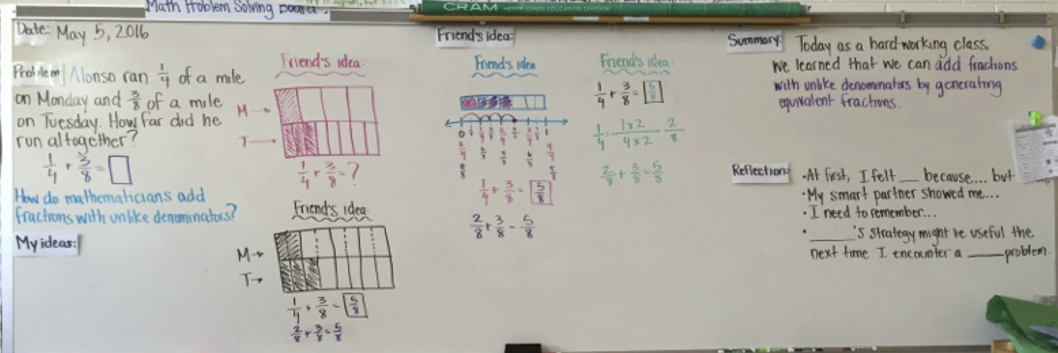

[1] Collaborative Lesson Research, http://www.lsalliance.org/clr-a-powerful-form-of-lesson-study/
[2] Teaching for Robust Understanding of Mathematics (TRU Math), http://map.mathshell.org/trumath.php

