Research Lesson Proposal for 7th grade Humanities

For the lesson on May 6, 2016

Chicago Lesson Study Conference

Dr. Jorge Prieto Math and Science Academy

Instructor: Roxana Gonzalez

Lesson plan developed by: Roxana Gonzalez, Dan Gray, Mariel Laureano, Celeste Locke

# Title of the Lesson: Flint Water Crisis: People Have the Right to Clean Water

Resources: Bill of Rights, Constitution, Declaration of Independence, Principles of Government

# Brief description of the lesson

Prior to the presented lesson, scholars will interact with multiple sources, establish an understanding of how people and situations are presented, and create an understanding that information is not always presented honestly. Then, scholars will build arguments, using appropriate citations, defending a claim or point of view. Finally, during the public lesson, scholars will evaluate the arguments of their peers, evaluate a new source, reevaluate their argument, and make adjustments to their original argument.

# Research Theme

­­Construct viable arguments and critique the reasoning of others through the use of various media sources.

# Goals of the Unit

1. Scholars will learn how to engage with different sources (written text, images, poems/song, videos, and documents), apply analytical skills to understand these sources, and use them to construct an argument.
2. Scholars will understand how claims and arguments they encounter can be understood and evaluated. Additionally, they will understand how those skills can be used to improve their own claims and arguments.

# Goals of the Lesson

1. Scholars will understand how to make a claim, using and citing sources.
2. Scholars will support their opinions with evidence from the sources. Those sources will be presented as a direct quote or a paraphrase and all sources will be cited.
3. Scholars will be able to recognize that facts can be used to support opposing points of view.
4. After reading a fourth source, scholars will analyze their evidence, making adjustments to their original argument as needed.

# Relationship of the Unit to the Standards

1. Studying and analyzing The Constitution and Bill of Rights will provide the background information scholars need to understand and evaluate arguments and claims that challenge or abridge the civil rights of another person.
2. Previous work in evaluating articles and primary sources provides a basis for scholars to approach new materials with a critical lens.
3. The *Read Like a Historian Framework* (Appendix A) has been used in the classroom since the beginning of the year. This framework requires scholars evaluate reading with the following aspects in mind: Who wrote it? Who was the intended audience? What was the context? Will other documents or articles confirm, support, or contradict the presented ideas?

|  |  |  |
| --- | --- | --- |
| Related prior learning standards | Learning standards for this unit | Related later learning standards |
| CCSS. WHST 6-8.1  Write arguments focused on *discipline-specific content.* | [CCSS.ELA-LITERACY.RI.7.3](http://www.corestandards.org/ELA-Literacy/RI/7/3/)  Analyze the interactions between individuals, events, and ideas in a text (e.g., how ideas influence individuals or events, or how individuals influence ideas or events).  [CCSS.ELA-LITERACY.RI.7.6](http://www.corestandards.org/ELA-Literacy/RI/7/6/)  Determine an author's point of view or purpose in a text and analyze how the author distinguishes his or her position from that of others.  CC ELA RI 7.8 Trace and evaluate the argument and specific claims in a text, assessing whether the reasoning is sound and the evidence is relevant and sufficient to support the claims. | [CCSS.ELA-LITERACY.RI.7.7](http://www.corestandards.org/ELA-Literacy/RI/7/7/)  Compare and contrast a text to an audio, video, or multimedia version of the text, analyzing each medium's portrayal of the subject (e.g., how the delivery of a speech affects the impact of the words). |

# Background and Rationale

Traditionally, social studies and language arts have been taught as two distinct upper elementary classes with different instructional themes. Our research theme, *Construct viable arguments and critique the reasoning of others through the use of various media sources*, is our attempt to build a humanities class that strengthens the connection between these two classes. In the past, we have successfully engaged scholars with a variety of sources and required scholars to analyze individual sources such as primary sources, secondary text and documents, images/pictures, video sources, speeches and poems/songs. In this research lesson, we will guide scholars a step further asking scholars to analyze sources and use those sources to build a logical argument for a specific claim. We have learned that scholars who are engaged in meaningful and current topics are more likely to engage in academically rigorous discussions and debate. Another rationale for this forum is our understanding of scholar motivation and its relationship to persistence: scholars who are engaged in conversations requiring or leading to empathy will persist during investigations with difficult texts because the issues are or become important to them.

Choosing to have scholars investigate the Flint Water Crisis will leverage empathy, while scholars develop an understanding of the frustration of Flint citizens. Using this topic will also allow scholars to empathize with people who have been disenfranchised. We are expecting scholars to ask, “Has that happened in Chicago? What would we do if this happened here?” Then we can initiate the conversation about civic engagement, and the rights of citizens based on the understanding of the documents that the scholars have been studying (The Bill of Rights, The Constitution, the principles of government, and the Declaration of Independence).

Scholars are learning about the rights and responsibilities for both government and citizens. Scholars have engaged with complex text and multiple sources for historical topics in previous lessons. This lesson will be a shift to analyzing current topics. In previous lessons throughout the year scholars have engaged with multiple sources on one topic to answer a focus question. For example, scholars analyzed two documents related to the Stamp Act prior to the American Revolution and used the sources to construct an argument that answered the question, “Why were the colonist upset about the Stamp Act” and “Did the Constitution guard against tyranny?” We will be using the same structure and systems to analyze the multiple documents so the scholars will be familiar with the format. We anticipate that this topic will inspire lively discussion and a high level of engagement.

# Research

This research lesson is designed with scholar’s reading abilities in mind. We are informed by our scholar’s performance on the Fountas and Pinnell Benchmark Assessment System levels from March 2016. The average reading level for this homeroom is a level X. Scholars who are reading at level X are able to think within the text, think beyond the text, and think about the text. Scholars reading at a level X can:

*“...automatically adjust strategic actions to skillfully use a genre. Readers will encounter mature themes that expand their knowledge of social issues. Themes are multidimensional and may be understood on several levels. Readers may be challenged by a heavy load of content-specific and technical words. scholars use information in an integrated way, using complex graphics and texts that present content requiring background knowledge. Many texts require knowledge of historical events and may contain language that is archaic.”*

A level X scholar will notice a writer’s perspective, identify multiple points of view, and derive the author’s implicit stated purpose. Furthermore, scholars reading at this level can critique texts by using sources of information to check for authenticity, and discuss whether social issues and different cultural groups are accurately represented in a text.

Along with reading levels we also took into account motivation and its effect on comprehension. Multiple researchers have proven that engagement with a text increases a reader’s ability to overcome higher vocabulary and increased text complexity. Rosenblatt’s transactional theory emphasizes the importance of text and task. What is inherent in the text is changed by what a scholar brings to a text. What is the task? What is the scholar being asked to “get” from the text? The scholar’s relationship to the text changes as they discuss their initial understandings of the text and it is in this place that scholars begin to question their understanding and push themselves as readers. They are motivated to read further and gain a greater understanding. Motivated readers will use more reading strategies and demonstrate persistence in order to participate in a text with which they want to interact (Butcher & Kintsch, 2003; Schallert & Martin, 2003).

Given our understanding of scholar reading levels and the role of motivation, we’ve designed our lesson and chosen texts that scholars can access, that will develop empathy, and will motivate scholars to apply their understandings to other current challenges in society. It is in learning to interrogate the reliability and claims of a particular source that scholars begin to engage in the sorts of activities that lie at the heart of historical thinking (Reisman & Wineburg, 2008; Wineburg 2001; Wineburg, Martin, & MonteSano, 2011).

# Unit Plan

The research lesson will be taught as part of the Social Studies Constitution and Bill of Rights Unit. Prior to this unit scholars studied early American History from the “Era of Discovery” to “The Birth of our Country.” The scholars will study the Constitution, branches of government, and governmental checks and balances in depth in preparation for this unit. The study of the Bill of Rights will guide scholars to contextually understand how this document impacts the opportunities and obstacles that affect our daily lives.

|  |  |  |
| --- | --- | --- |
| **Lesson** | **Social Studies Content**  **Learning goal and tasks** | **ELA**  **Learning goals and tasks** |
| 1 | *Learning goal:* Scholars will construct an argument using 3 texts/resources.  *Task:* Scholars will deconstruct the question of “Were the Flint, Michigan residents’ civil rights denied or upheld in regards to the Flint, Michigan water crisis?” Scholars will be given a graphic organizer to use the “Read Like a Historian Model” to capture their thinking while reading three informational texts. (Appendix B) | *Learning goal:* Use precise language and domain-specific vocabulary to explain a topic.  *Tasks:* Examine the prompt, “Were the Flint, Michigan residents’ civil rights denied or upheld in regards to the Flint, Michigan water crisis?” and label each word’s part of speech. Close read and annotate one of the shared articles their group has chosen to use as evidence to answer the prompt. Scholars will use the provided rubric and evaluate their Timeglider timeline. |
| 2 | *Learning goal*: Trace and evaluate the argument and specific claims in a text. Identify main idea and specific details, supporting the author’s intended message, so that scholars can construct claim statements associated with the group’s point of view.  *Task:* Scholars will use the Read Like a Historian Model to read and understand their chosen 2nd and 3rd sources. Scholars will use their gathered evidence to construct an argument statement, which is an answer to the focus question, “Were Flint, Michigan residents’ civil rights denied or upheld in regards to the Flint Water Crisis? | *Learning goal:* Trace and evaluate the argument and specific claims in a text. Identify main idea and specific details that support the author’s intended message.  Scholars will also understand how parts of speech help them better understand a text.  *Task:* Scholars will identify 3 examples of adjectives that modify nouns, providing focused or specific information connected to the prompt.  Scholars will close read the 2nd of the 3 articles selected for their argumentative writing. |
| 3 | *Learning goal:* Scholars will incorporate knowledge from the Constitution and Bill of Rights, and the 7 principles of government (Popular Sovereignty, Republicanism, Federalism, Separation of Powers, Checks and Balances, Limited Government, and Individual Rights) into their argument.  *Task:* Scholars will finalize their arguments and verify that their argument includes evidence from sources. | *Learning goal:* Trace and evaluate the argument and specific claims in a text.  *Task*: Scholars will support their group’s claim by adding details and text evidence to their argument.  Scholars will be reminded to add citations for text evidence and expected to include those citations in their final arguments. |
| 4 | ***Research Lesson:***  *Learning goal:* Analyze and evaluate their final argument piece.  *Task:*  Scholars will be presented with a new piece of information in the form of a video. Scholars will consider this new piece of information as they revise their argument on the Flint water crisis. | *Learning goal:* Evaluate and critique the revised arguments of other scholars.  *Task:* Scholars will be presented with a new piece of evidence to analyze. Once they have reviewed it they will evaluate their current argument and include details from the new source to improve their argumentative piece. |

# Lesson Plan

Based on your understanding of the Bill of Rights, create an argument to address the question, “Were the residents of Flint’s rights infringed upon or upheld? “

|  |  |  |
| --- | --- | --- |
| **Steps, Learning Activities**  **Teacher’s Questions and Expected scholar Reactions** | **Anticipated Responses and Teacher Supports** | **Points of Evaluation** |
| 1. **Introduction/Launch**   Review argument developed over the course of the two week unit.    Scholars share out their position and current argument regarding the rights of the residents of Flint, Michigan to clean water.  Groups will exchange members and provide criticism on the group’s argument in response to the question, “ How is evidence used to support the argument of whether or not the rights of the Flint Michigan residents’ rights were upheld or denied?”  At the beginning of the week scholars choose 3 sources from the available sources to construct their current argument and used the **Read Like a Historian Framework** to pull evidence from each source to use in their arguments. | scholars might make grand overarching statements without having evidence to support idea. scholars might not approach the question with depth.  S: “This is another example of people who don’t care.”  T: “What differentiates between those who care and those who don’t? What holds everyone accountable?” | The following areas have been taught and should be apparent in the conversations and arguments:  -Do scholars have a context of the water crisis?  -Are scholars using content vocabulary in their argument and discussion?  -Are scholars referring to the Bill of Rights in their argument?  -Are scholars using and explaining evidence in their argument.  -Are scholars referring to the graphic organizer previously used to captures supporting text evidence? The graphic organizer follows the **Read Like A Historian Framework** (Appendix A)  -Do groups realize that their argument is incomplete?  -Is there a quote or a paraphrase that is text based?  -Is the quotation sourced? |
| 1. **Posing the Task**   “Today you are going to be presented with a 4th media source, at the end of class I’ll be asking you to answer the question, ‘How did having an additional source affect your argument?’ Keep that question in mind.”  “We are going to use our **Read Like a Historian** model to read and analyze the 4th source. Open your digital copy of the graphic organizer to record information about the 4th source. When adding information from this 4th source, make sure that you add information in a different color so that it can be distinguished from the original argument.”  Scholars will break off for independent work, evaluating the new text/media source and completing the graphic organizer. Scholars will then add the new evidence and adjust their argument. -- (20 minutes)  “How did the new media source affect your argument regarding the civil right of the residents of Flint to clean water?”  Through the video scholars will get information that the decisions on the source of water were made by an unelected official.  Scholars will understand that one person  (city manager) was trying to save money, while another was trying to keep people’s water safe (the elected city councilman.) | Teacher writes as Guiding Question on the board after sharing the task/purpose of the task.  If scholars are stuck on the **Read Like a Historian** model teacher will prompt them by reminding them of the steps within the model:  **Remember first you,**  Source the Source  What is it? What information does it provide  Who is my author, when was it written?  What was the original intended audience of the source?    Scholars will then complete Close Reading to be able to:  Use reading skills to understand the text  Along with the video scholars will be provided with the transcript of the interview. |  |
| 1. **Comparing and Discussing**   We started the lesson by reviewing our arguments and learned ways of strengthening our arguments  “Turn and talk in your group about the new information learned from this new source and how it affected your argument. Please be ready to share out with the whole group. |  |  |
| 1. **Summing up**   Teacher will pose the 2 guiding questions which launched the lesson  “Let’s revisit our two guiding questions. You will be writing a reflection exit slip with your responses. 1) Write an argument statement in response to our question, “In the context of the Flint Water Crisis, were the civil rights of the residents of Flint Michigan violated?  2) How did the additional source, the video, and the information it provided, affect your ability to write a persuasive argument?” |  |  |

# Evaluation

*What evidence was present indicating scholars were applying the Bill of Rights to the given media sources bridging language arts and social studies?*

*Did scholars use multiple sources to construct a developed argument indicating an abridgement or support of the person’s civil rights?*

# Board Plan

Essential and Guiding questions will be posted to focus scholars thinking during the lesson.

As well, the Teacher will utilize “Air-Server” and “Air-Play” to create a public form of sharing their work and thinking.

# Reflection

To be completed by the team after the lesson and discussion.

Appendix.

1. Read Like a Historian Framework | sheg.stanford.edu

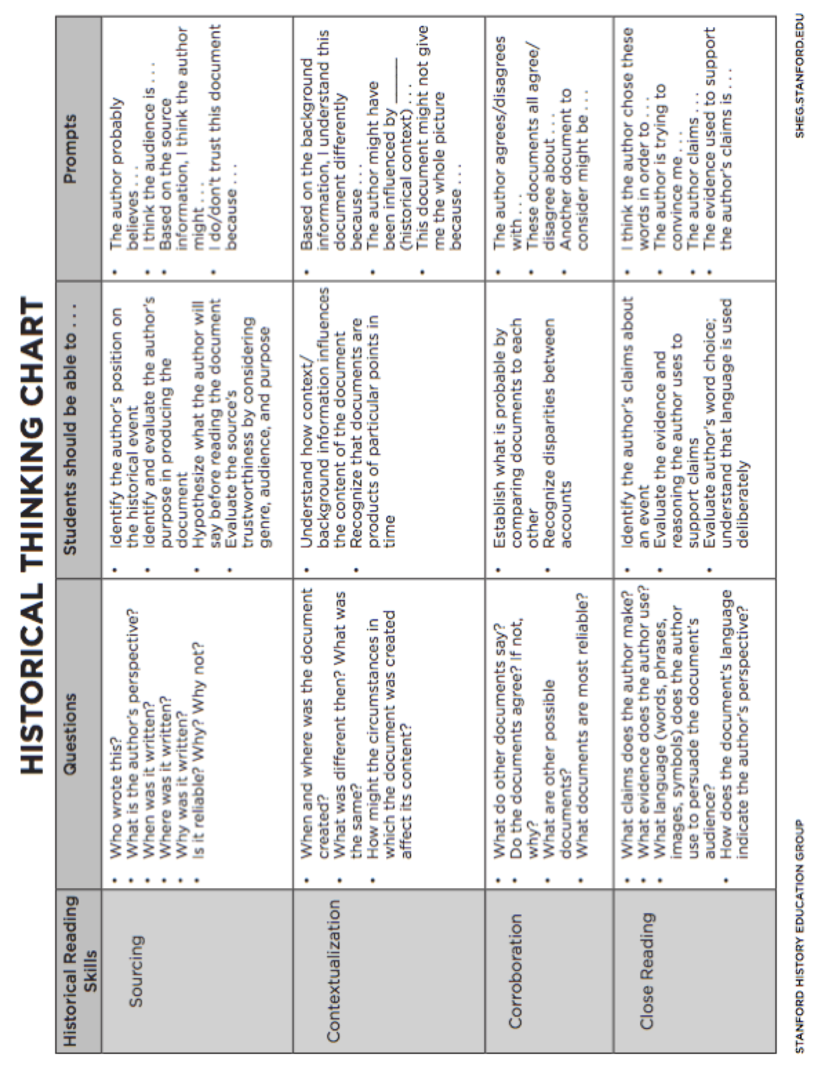

B. Read Like A Historian scholar Organizer

*Each scholar will have a copy of the graphic organizer as a live document in Google Drive.

