Grade 4 Mathematics Lesson Plan

Date: June 15, 2018

Period 5

Teacher: FUJIWARA, Yoshinori

1 Name of the unit: Division algorithm (1)

2 Goals of the unit

* Students will understand division of 2- and 3-digit numbers by 1-digit number and calculate accurately. They will further their ability to apply their knowledge and skill of division.

|  |  |
| --- | --- |
| Interest, Eagerness, and Attitude  [IEA] | * Students will recognize the merit of the basic calculations including divisions that are inverse of the basic multiplication facts in dividing 2- and 3-digit numbers by 1-digit numbers. They will try to use their knowledge in the new learning. |
| Mathematical Way of Thinking  [MWT] | * Students can think about how to calculate (2- and 3-digit ÷ 1-digit) using the division algorithm using their understanding of the structures of numbers and division calculations they have previously learned. They can represent and summarize their learning. |
| Mathematical Skills  [MS] | * Students will be able to calculate (2- and 3-digit ÷ 1-digit) using the division algorithm. * Students can calculate simple division mentally. |
| Knowledge and Understanding  [KU] | * Students will understand how to calculate (2- and 3-digit ÷ 1-digit). They will also understand the idea of times as much. |

3 About the unit

1. Mathematics

There are 4 aims of the unit based on what students learned in Grade 3.

1. Calculation of (2- and 3-digit ÷ 1-digit)

In Grade 4, students will learn division that goes beyond the inverse of the basic multiplication facts. However, by thinking in terms of 10s and 100s, the basic multiplication facts can be applied to these calculations. It is important for students to maser this way of thinking.

1. Mastering the division algorithm

Students need to develop the mastery of the division algorithm and its steps (divide, multiply, subtract, and bring-down). At the same time, they should calculate while keeping attention on the numbers and quantities involved so that they can avoid mistakes such as incorrect remainders and underestimated quotients.

1. Extending the meaning of division

Students will learn that division can be used to determine how many times as much one quantity is of another. This is an important foundation for their study of *wariai[1]* in Grade 5. We will incorporate double number line diagrams so that students can understand this idea visually.

1. Understanding properties of division

Division has the following property:

Given *a* ÷ *b* = *c*, (*a* × *m*) ÷ (*b* × *m*) = *c*, and (*a* ÷ *m*) ÷ (*b* ÷ *m*) = *c*

In this unit, students can use this property in estimating quotients.

1. Current state of students

The basic multiplication is a must for the study of division, and most students have developed the fluency. With respect to division students learned in Grade 3, most students understand the meaning of division and what quotients represent. However a few students misunderstood how to determine remainders. We believe that the reason for this mistake is due to their lack of clear understanding of the meaning of remainders and also their lack of attention to the quantities involved in division.

In the study of mathematics, several students need more time to determine the difference between a novel problem they are presented and what they have previously studied. It also take time for them to determine the important mathematical question that needs to be resolved in order to solve a problem.

About a half of students are hesitant of expressing their ideas, while the other half of students are eager to share their ideas. However, in spite of this difference, many students are participating in small group discussion.

1. About instruction

Based on the students’ current state, we want our instruction to bring out and nurture the following dispositions.

1. Students who can approach novel tasks with a plan based on their prior learning

We want our students to be aware of their prior learning and identify the differences in a novel task so that they can approach it with a plan. To do so, we want to repeatedly emphasize journaling so that students can use their own notebooks to look back and construct their ideas.

1. Students who understand the connections between concrete manipulations and the numerical manipulations in the algorithm

We want to incorporate activities in which students will manipulate bundles of 10 or 100 colored papers. We want students to be constantly aware of the number structures, such as even though the digit may be “2,” if it is in the tens place, we are dealing with 20.

1. Students who can express their ideas using a variety of representations

We will try to incorporate a variety of representations such as pictures, diagrams, or double number lines so that problem situations and expressions/equations may be appropriately modeled. We want students to nurture the disposition to compare their own representations with their peers’ representations as they listen to their ideas.

1. Students who can reason while incorporating their peers’ ideas

We will incorporate as many opportunities for students to engage in small group discussion time throughout the unit. In this way, we want students to experience the merits of listening to each other and generating better ideas through discussion. Such experiences will then encourage them to engage in the whole class discussion more actively.

4 Strategies to make discussion that promote subjective, interactive and deep learning[2]

◎ Strategies in today’s lesson

〇 Strategies incorporated throughout the unit

1. Ways to pose and identify the mathematical purpose of the learning task during the introduction

〇 Strategy to help students pay attention to the structure of numbers

From the beginning of the unit, we encouraged students to manipulate bundles of papers. As we studied the way to notate the division algorithm, we incorporated number cards and the web page, <http://www.mowmowmow.com/math/flash/s4/3keta.html>, so that students can think about the units. In this way, we tried to help students understand the logic behind the algorithm notation.

〇 Strategy to help students develop a plan

We have tried to emphasize what we could determine out using our prior learning. In this way, we tried to bring out what needs to be figured out and develop a plan.

◎ Strategy to connect the steps of the division algorithm with the structure of numbers

We will display incorrect calculations along with the correct one. By comparing different calculations, students can recognize the logic behind the steps of the division algorithm.

〇 Strategy to help students pay attention to their prior learning constantly

In the classroom, we have displays of posters that show what we have learned already, as well as topics of discussion we had. In this way, students can develop the disposition to make use of what we have learned previously.

1. Discussion activities (purposes, formats, procedures, methods, etc.)

〇 Strategy to make discussion more active

In order to have active pair and small group discussion, we developed a seating arrangement so that students with similar levels of mathematics achievement are seated together. By having students who might reason at similar pace, we hope that more students will have experiences of developing a new idea through discussion that was not possible individually during independent problem solving time or correcting and modifying their ideas by incorporating their peers’ ideas.

◎ Strategy to help students listen to each other’s idea more effectively

* After independent problem solving time, we will have time for pair discussion. By sharing their own ideas in pairs, we hope students will become more confident about sharing their ideas and participate in the whole class discussion.
* By setting up a time for students to gather near the board without their notebook so that they can focus on listening to each other. This will help them catch each other’s ideas. We will set up a separate time when they can correct or modify their own ideas based on what they heard from others.

1. Mathematics, teacher questioning, and board writing

◎ Strategy to help students make connections among their ideas

While students are thinking individually or in small groups, we will have students write their ideas in small whiteboards. We will use students’ writing to demonstrate how their ideas can be extended, as well as making comparisons and identify similar points more easily.

◎ Strategy to make the intention of the question clear

When the task is posed to students, we made animations showing how the division algorithm was carried out. By making more dynamic representations, we hope students will be able to identify the differences in calculation steps clearly.

5 Unit Plan (17 lessons)

|  |  |
| --- | --- |
| Lesson |  |
| 0 | Readiness test/review of previous learning |
| 1 | Think about ways to calculate 80 ÷ 4. (Dividing multiples of 10) |
| 2 | Think about ways to calculate 600 ÷ 3.  Think about how to calculate 300 ÷ 5. (Dividing multiples of 100) |
| 3 | Think about ways to calculate 72 ÷ 3. (Combining bundles of 10 and 2) |
| 4 | Think about ways to calculate 72 ÷ 3. Learn the division algorithm. (Connecting the ideas from the previous lesson to the division algorithm) |
| 5 | Think about ways to calculate 76 ÷ 3. Learn the division algorithm. (Division with remainders using the algorithm) |
| 6 | Mastering the algorithm for 2-digit ÷ 1-digit (with remainders) (Mastering the division algorithm with remainders) |
| 7 | Think about ways to notate 86 ÷ 4 and 619 ÷ 3 using the division algorithm. (Digits in the tens place are divisible by the divisor. The ones place in the quotient is 0.) |
| 8 | Think about ways to calculate 734 ÷ 5. (None of the places is divisible.) |
| 9 | Ways to calculate 843 ÷ 4 and 619 ÷ 3 using the algorithm. (An empty place in quotients) |
| 10  (Today) | Think about ways to calculate 256 ÷ 4. (The hundreds place in the quotient is empty. Must think about 25 ÷ 4) |
| 11 | Think about ways to calculate 427 ÷ 5, then calculate using the algorithm. ((The hundreds place in the quotient is empty, and there is a remainder) |
| 12 | Think about how many times as long is an adult whale as a juvenile whale. (Using division to find out how many times as much) |
| 13 | Determine an adult giraffe’s height given a juvenile giraffe’s height and how many times as tall. (Determine the compared quantity using multiplication) |
| 14 | Determine the weight of a juvenile cheetah given the weight of an adult cheetah and how many times as much. (Determine the base quantity by transforming equation) |
| 15 | Think about ways to calculate 74 ÷ 2 mentally. (Mental calculation using the property of division) |
| 16/17 | Mastering the content of the unit. (Mastery of various types of division) |

6 Today’s lesson (Lesson # 10 out of 17)

1. Goals

Students will understand how to calculate 3-digit ÷ 1-digit = 2-digit (the hundreds place in the quotient is empty) and be able to explain it.

1. Flow of the lesson

|  |  |  |
| --- | --- | --- |
| Steps | Instructional activity  Content | Teacher move (〇)  Assessment (□) |
| 1 Grasp the task and the aim. | * What is the calculation needed?   256 sheets of colored papers are to be shared equally among 4 people How many sheets of paper will each person receive?   * 256 ÷ 4. * Let’s look at 3 different ways people calculated this.   **Let’s explain how to calculate correctly.** | 〇 By grasping what is different in today’s task from those they have been studying, we will clarify the aim of today’s lesson.  〇 Display the 3 calculations one at a time. |
| 2 Indep. problem solving  3 Share ideas in small groups  4 Share ideas as a whole class | * Let’s explain how to calculate this problem using diagrams, words and equations so that your friends can understand it.   [Explain using a diagram]  C:\Users\twatanab\AppData\Local\Temp\SNAGHTML28c66fde.PNG  [Explain using equations and words]  First, exchange bundles of 100 into bundles of 10. Then, give each person 60.  240 ÷ 4 = 60  Combine the remaining bundle of 10 with 6, then divide by 4.  16 ÷ 4 = 4.  The total of the quotients is 64.  60 + 4 = 64. | 〇 If any student is having trouble getting started, encourage him/her to look at the posters in the classroom or his/her notebook.  〇 Remind students to use models and explanations that are understandable to their friends.  〇 Do not let students write long sentences on their whiteboards.  □ Students are summarizing and explain the reason behind the steps of the division algorithm using diagrams and equations. [MWT] (Observation/ Presentation/Notebook) |
| 5 Summarize | * Let’s look back on what we studied today. * For the next time, think about how we can notate the calculation with the division algorithm using the ideas we discussed today. |  |

Board writing Plan

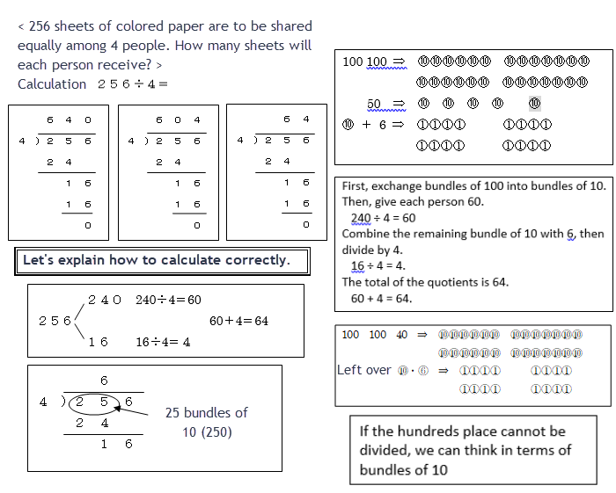

1. The Japanese term *wariai* is difficult to translate into English. It describes multiplicative relationship of two quantities, and it involves aspects of ratio, rate and proportion.
2. “Subjective, interactive, and deep learning” is a phrase introduced by the Japanese Ministry of Education to articulate “active learning.” “Subjective learning” may be characterized by eagerness, persistence, and reflectiveness.